**FATHOM SOFTWARE ASSIGNMENT**

**Date : 09:07:2023**

**Problem Statement :**

* Create web application for client by using Basic Authentication
* Models - Registration and LogIn page
* New user should register first, and data should be stored in Database
* Only valid user can access further webpages
* On successful login , display user registered information from Database

**Solution :**

**FATHOM APP**

**Front End Technologies:**

* **ReactJs**
* **Bootstrap**
* **HTML**
* **CSS**
* **JSX**

**Back End Technologies:**

* **NodeJS**
* **Express**
* **Mongoose**
* **MongoDB compass**

Features I added in Project :

* If user is New then direct him to register first
* It is compulsory to fill all the fields of registration form by user
* Error occure on wrong input entered by User

For example , enter text in pincode field

* Already registered user cannot register again.

User can register with new username/email id

* Check valid password for registration
* Successful MongoDB database entry
* User Authentication: Check user credentials
* Successfully login by valid user
* Only valid user able to visit his/her profile

Advanced Features we can add to this project

* JWT(json web token) Authentication & Authorization
* SignIn using Google Account Email-Id
* Authentication by OTP genearation
* Input validation using ‘Reguler Expressions(regEx)’
* Features like Edit and Delete profile details by user.

Please go through the details methioned below

Home Page

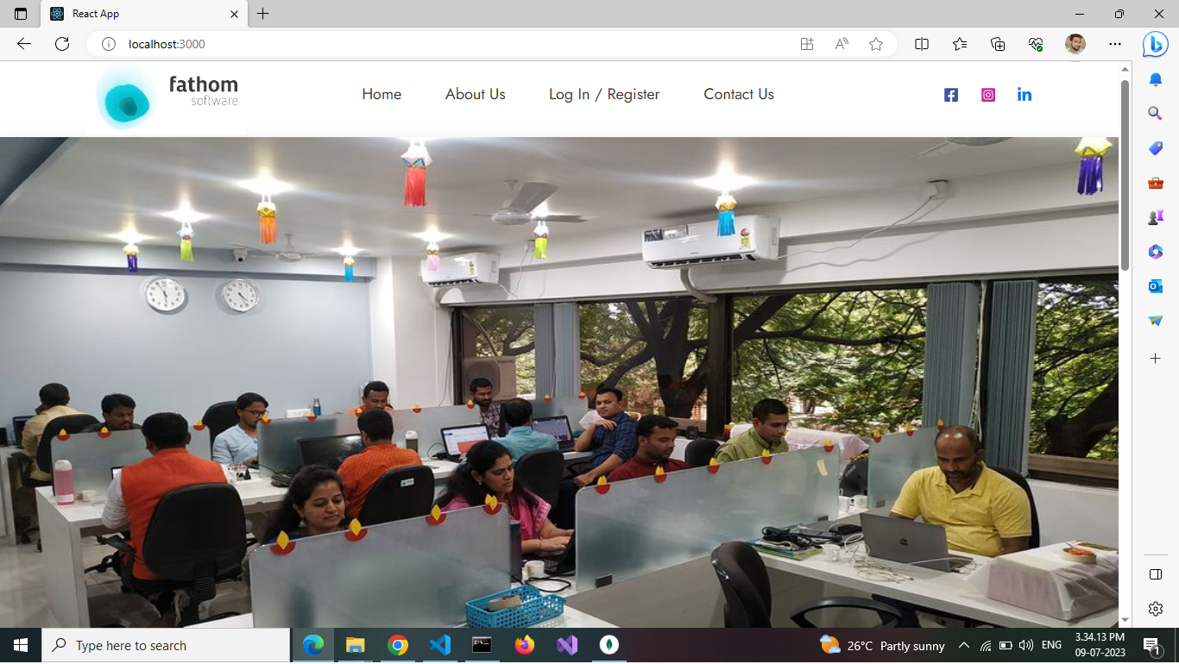

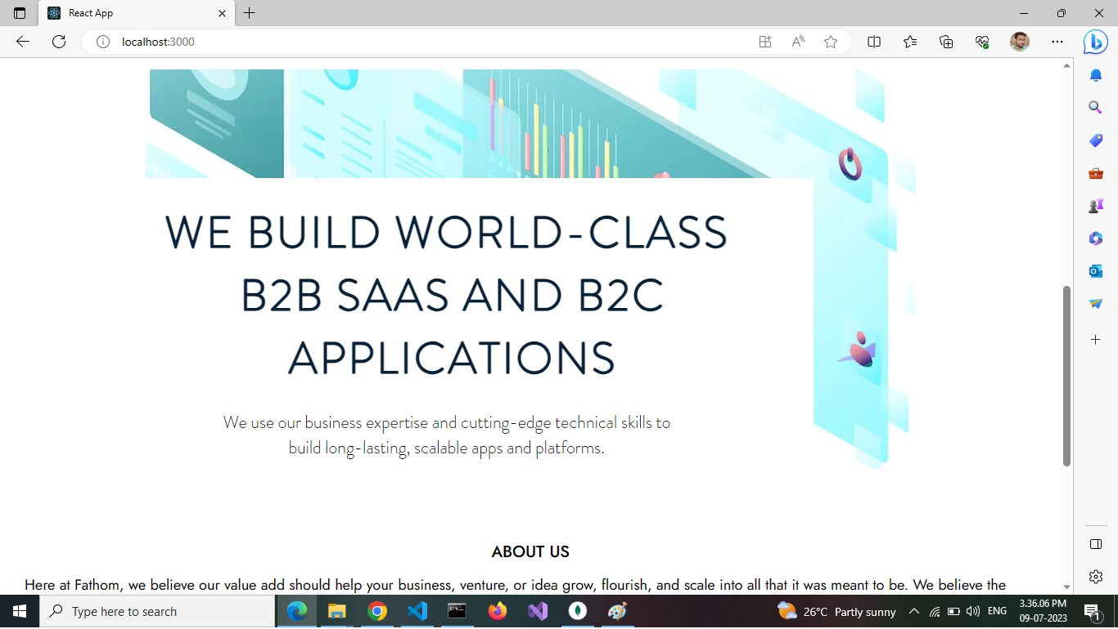

If user is New then direct him to register first

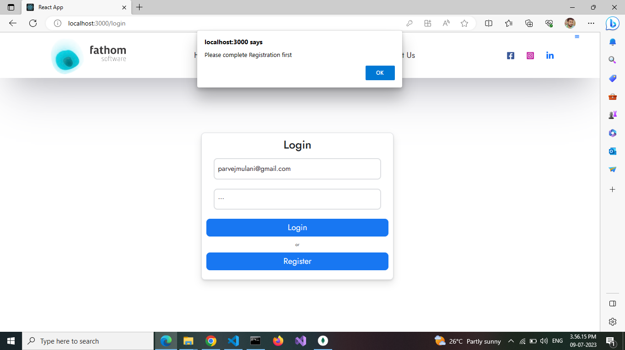

Registration form

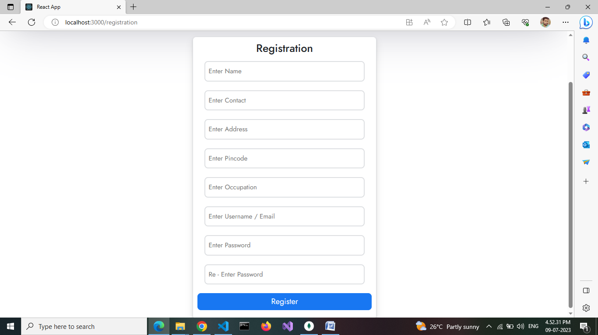

It is compulsory to fill all the fields of registration form by user

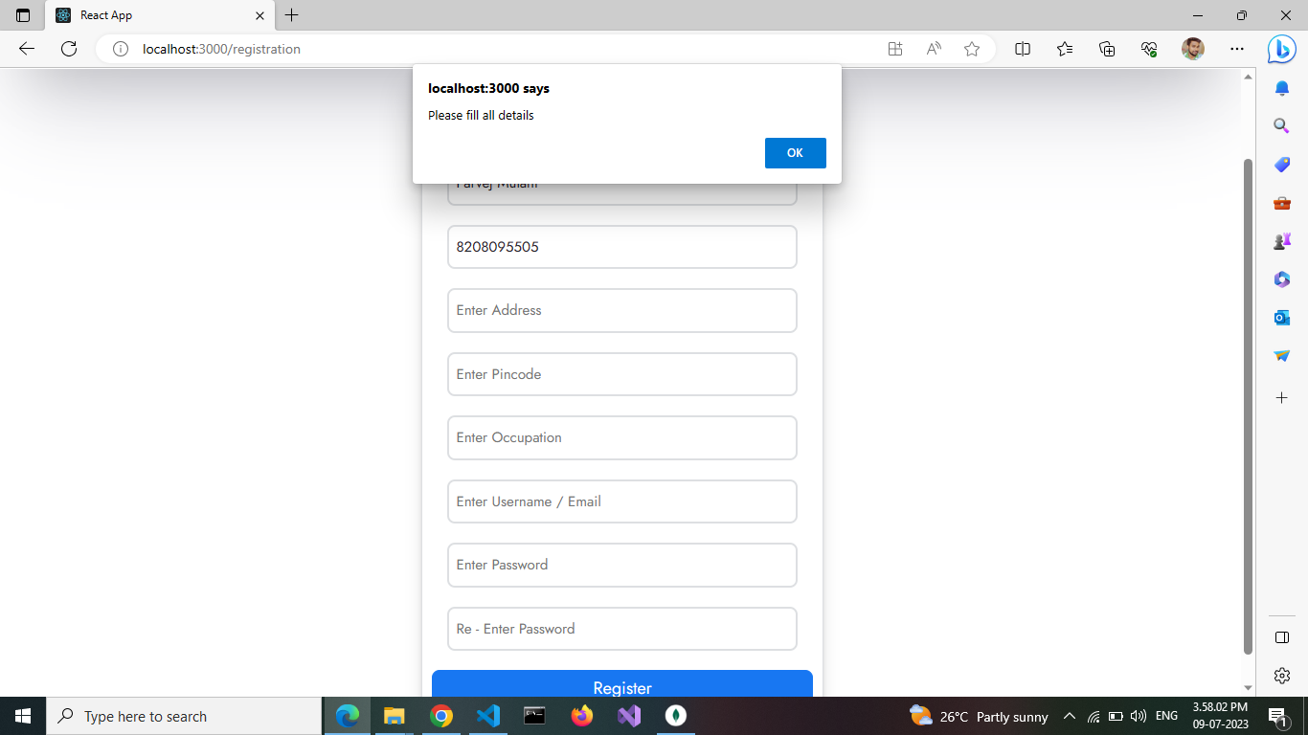

Error for wrong input entered by User

For example , enter text in pincode field

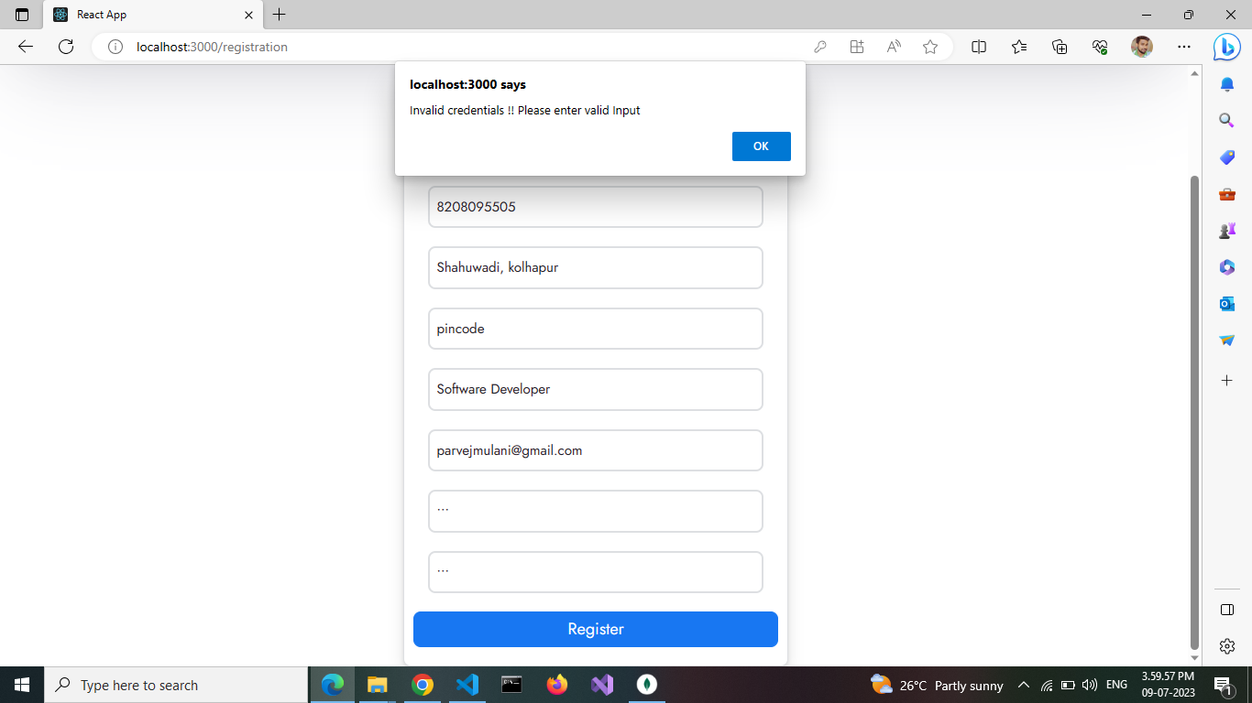

Already registered user cannot register again

User can register with new username/email id 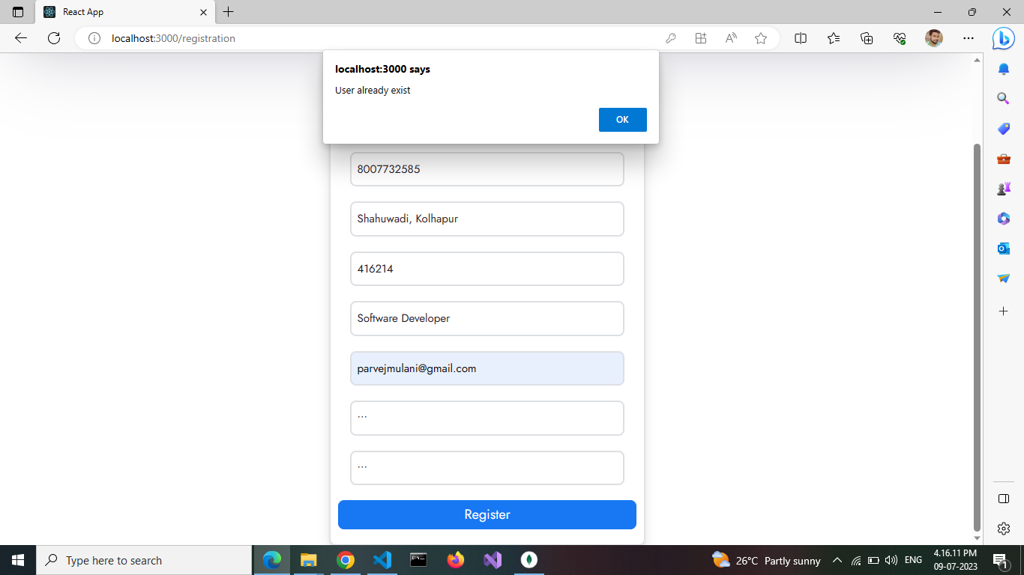

Check valid password for regisration

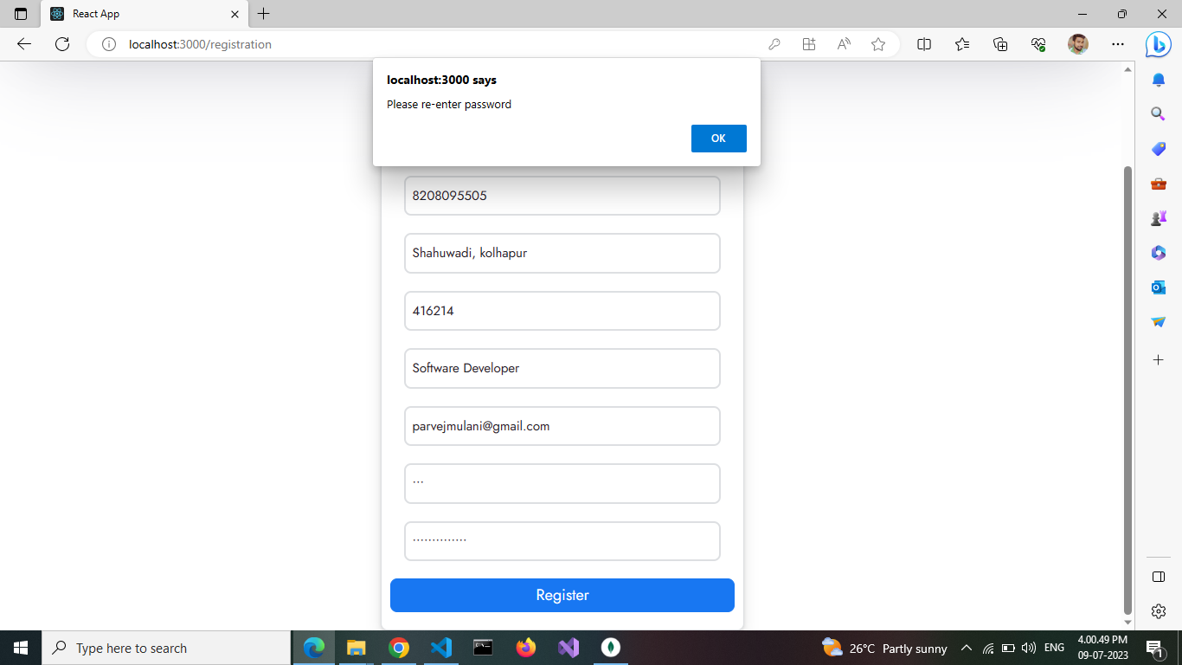

Successful registration

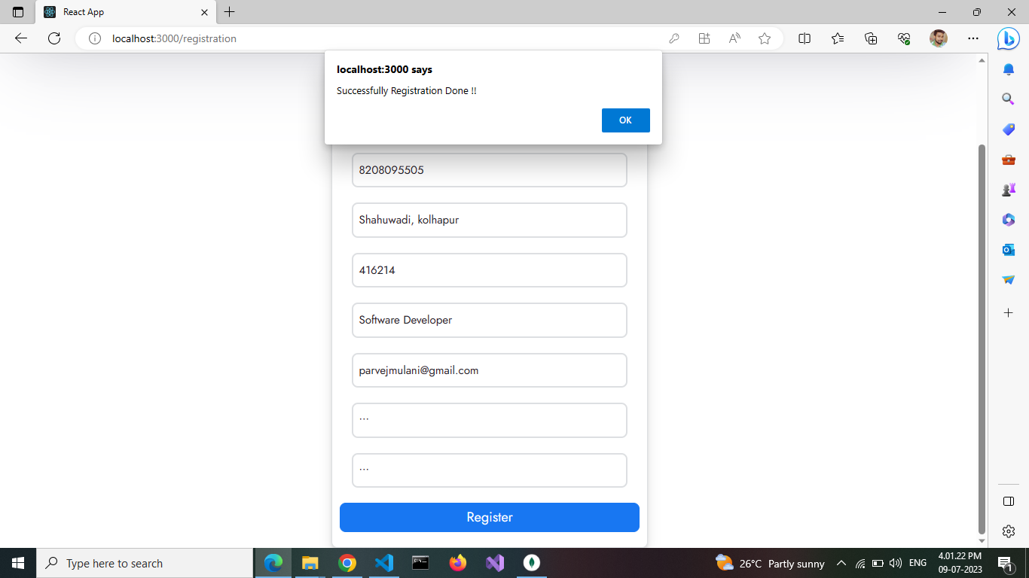

MongoDB database entry

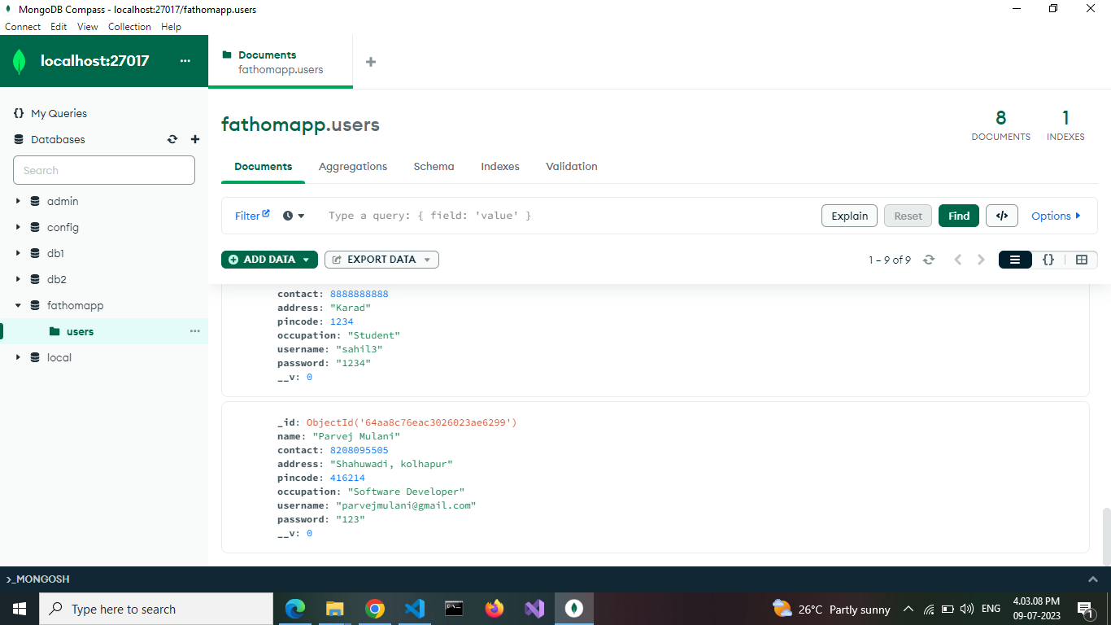

User LogIn

User Authentication: Check user credentials

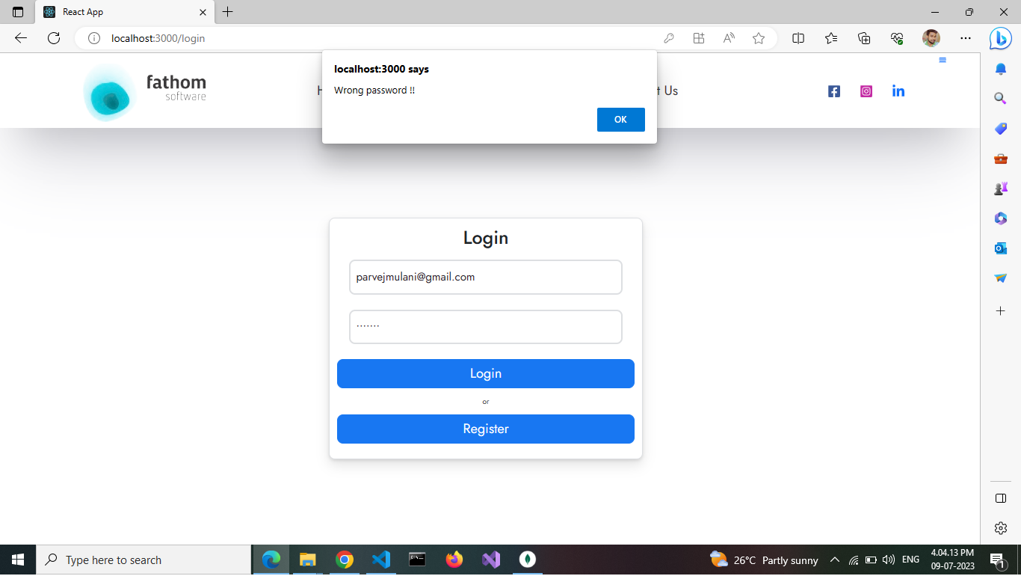

Successfully login by valid user

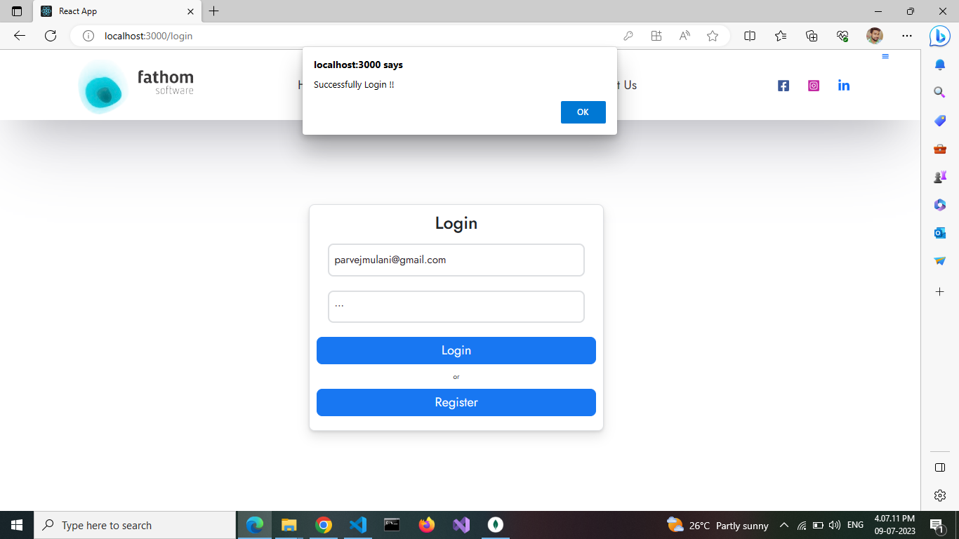

Only valid user able to visit his/her profile

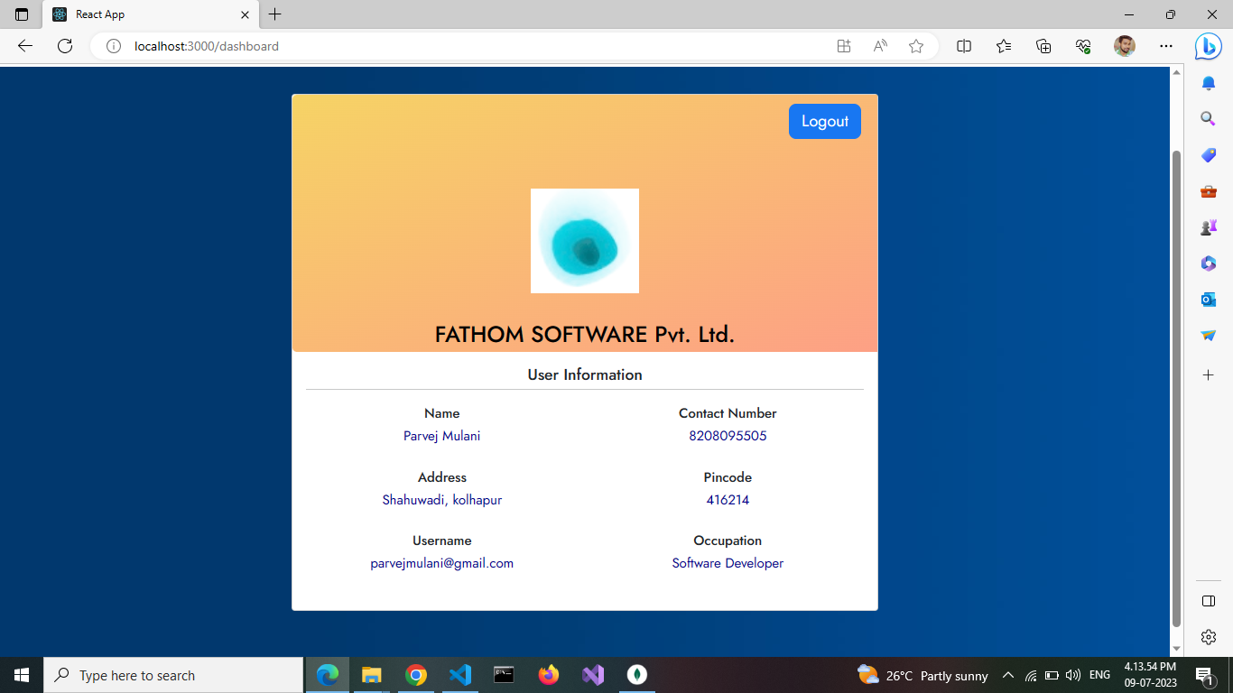

**THANK YOU !!**